HRC45 Square and Mill for steel 2F/4F
Specification | PRICE/rub | Specification | PRICE/rub
1.0*3*4D*50L | 188 | 12.0*60*12D*150L | 2426
1.5*4*40*50L | 188 | 14.0*60*14D*150L | 3508
2.0*5*40*50L | 188 | 16.0*60*16D*150L | 4476
2.5*7*4D*50L | 188 | 18.0*60*18D*150L | 5294
3.0*8*40*50L | 188 | 20.0*60*20D*150L | 6107
3.5*10*4D*50L | 188 | 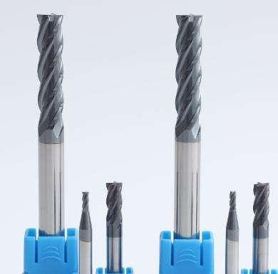  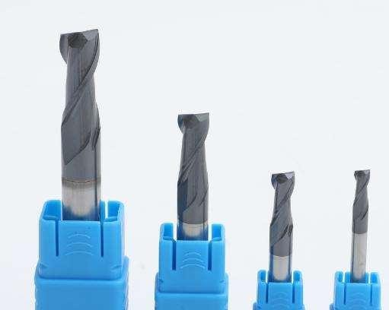
3.0*8*3D*50L | 188
4.0*10*4D*50L | 188
5.0*13*6D*50L | 339
5.0*13*5D*50L | 339
1.0*3*6D*50L | 339
1.5*4*60*50L | 339
2.0*5*6D*50L | 339
2.5*7*60*50L | 339
3.0*8*6D*50L | 339
3.5*10*6D*50L | 339
4.0*10*6D*50L | 339
4.5*12*6D*50L | 339
6.0*15*6D*50L | 339
8.0*20*8D*60L | 602
10.0*25*10D*75L | 1008
12.0*30*12D*75L | 1375
14.0*35*14D*80L | 2354
14*45*140*100L | 2088
16*45*16D*100L | 2746
18*45*18D*100L | 3327
20*45*20D*100L | 4055
3.0*12*3D*75L | 263
4.0*16*4D*75L | 263
5.0*20*5D*75L | 443
6.0*25*6D*75L | 443
8.0*28*8D*75L | 745
3.0*15*3D*100L | 252
4.0*20*4D*100L | 252
5.0*25*5D*100L | 462
6.0*30*6D*100L | 462
8.0*3 5*8D*100L | 729
10.0*40*10D*100L | 1114
12.0*45*120*100L | 1491
6.0*40*6D*100L | 866
8.0*50*8D*100L | 1342
10.0*50*10D*100L | 1993

HRC45 Square and Mill for alminum 3F/2F
Specification | PRICE/rub | Specification | PRICE/rub
1.0*3*4D*50L | 188 | 10.0*50*10D*150L | 1993
1.5*5*40*50L | 188 | 12.0*60*12D*150L | 2426
2.0*6*4D*50L | 188 | 14.0*65*14D*150L | 3508
2.5*8*40*50L | 188 | 16.0*65*16D*150L | 4476
3.0*9*40*50L | 188 | 18.0*70*18D*150L | 5294
3.5*12*4D*50L | 188 | 20.0*70*20D*150L | 6107
3.0*9*3D*50L | 188 | 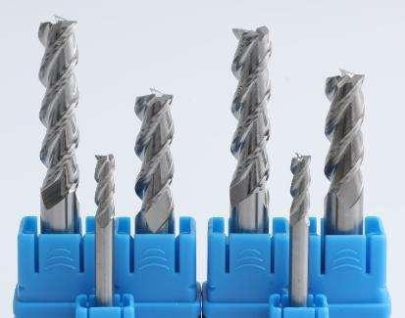  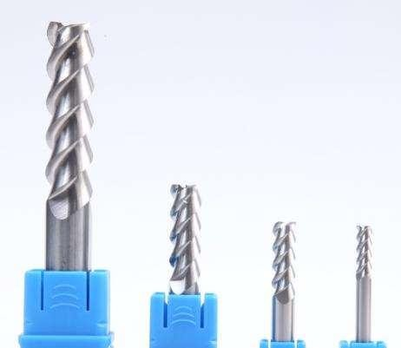
4.0*12*4D*50L | 188
5.0*15*6D*50L | 339
5.0*15*5D*50L | 339
1.0*3*6D*50L | 339
1.5*4*6D*50L | 339
2.0*6*60*50L | 339
2.5*7*6D*50L | 339
3.0*9*6D*50L | 339
3.5*10*6D*50L | 339
4.0*12*6D*50L | 339
4.5*10*6D*50L | 339
6.0*18*6D*50L | 339
8.0*24*8D*60L | 602
10.0*30*10D*75L | 1008
12.0*36*12D*75L | 1375
14.0*35*14D*80L | 2354
14*45*140*100L | 2088
16*45*16D*100L | 2746
18*45*18D*100L | 3327
20*45*20D*100L | 4055
3.0*12*3D*75L | 263
4.0*20*4D*75L | 263
5.0*20*5D*75L | 443
6.0*30*6D*75L | 443
8.0*35*8D*75L | 745
3.0*15*3D*100L | 252
4.0*25*4D*100L | 252
5.0*25*5D*100L | 462
6.0*30*6D*100L | 462
8.0*40*8D*100L | 729
10.0*40*10D*100L | 1114
12.0*45*12 D*100L | 1491
6.0*40*6D*100L | 866
8.0*50*80*100L | 1342

HRC45 Ballnose 2F (for steel)
Specification | PRICE/rub | Specification | PRICE/rub
R0.5*2*4D*50L | 235 | R9.0*36.18D*150L | 6136
R0.75*3*4D*50L | 235 | R10.0*40*20D*150L | 7124
R1.0*4*4D*50L | 235 | 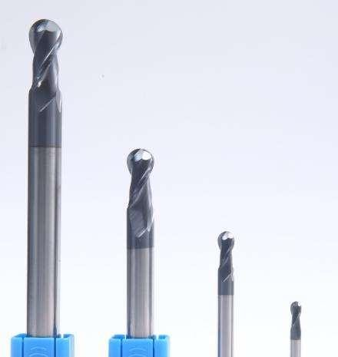
R1.25*5*4D*50L | 235
R1.5*6*3D*50L | 235
R1.5*6*4D*50L | 235
R1.75*7*4D*50L | 235
R2.0*8*4D*50L | 235
R1*4*6D*50L | 396
R1.5*6*6D*50L | 396
R2*6*6D*50L | 396
R2.5*10*5D*50L | 396
R2.5*10*6D*50L | 396
R3.0*12*6D*50L | 396
R3.5*14*8D*60L | 704
R4.0*16*8D*60L | 704
R4.5*18*10D*75 | 1177
R5.0*20*10D*75L | 1177
R5.5*22*12D*75L | 1603
R6.0*24*12D*75L | 1603
R7.0*28*14*80 | 2746
R7.0*28*14D*100L | 2434
R8.0*32*16D*100L | 2984
R9.0*36*18D*100L | 3881
R10.0*40*20D*100L | 4430
R2.0*8*4D*75L | 330
R1.5*6*3D*75L | 330
R3.0*12*6D*75L | 518
R4.0*16*8D*75L | 869
R1.5*6*3D*100L | 315
R2.0*8*4D*100L | 315
R3.0*12*6D*100L | 541
R4.0*16*8 D*100L | 853
R5.0*20* 10 D*100L | 1301
R6.0*24*12D*100L | 1739
R3.0*12*6D*150L | 1010
R4.0*16*8D*150L | 1567
R5.0*20*10D*150L | 2324
R6.0*24*12D*100L | 2829
R7.0*28*14D*100L | 4093
R8.0*32*16D*100L | 5221

HRC45 Corner Radius (for steel)
Specification | PRICE/rub | Specification | PRICE/rub
3R0.5*8*3D*50L | 314 | 10R1.0*50*10D*150L | 2950
3R1.0*8*3D*50L | 314 | 12R1.5*60*10D*150L | 3585
3R0.5*8*4D*50L | 314 | 12R1.0*60*10D*150L | 3585
3R1.0*8*4D*50L | 314 | 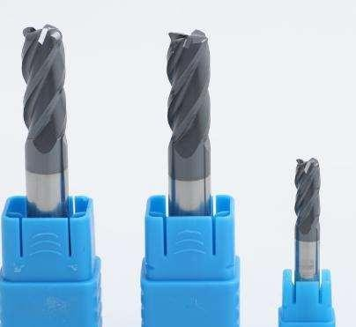
4R0.5*10*4D*50L | 314
4R1.0*10*4D*50L | 314
6R0.5*15*6D*50L | 590
6R1.0*15*6D*50L | 590
8R0.5*20*8 D*60L | 963
8R1.0*20*8D*60L | 963
8R2.0*20*8D*60L | 963
10R0.5*25*10D*75L | 1528
10R1.0*25*10D*75L | 1528
10R2.0*25*10D*75L | 1528
12R0.5*30*12D*75L | 2024
12R1.0*30*12D*75L | 2024
12R2.0*30*12D*75L | 2024
12R3.0*30*12D*75L | 2024
3R0.5*12*3D*75L | 465
3R1*12*3D*75L | 465
4R0.5*16*4D*75L | 465
4R1.0*16*4D*75L | 465
6R0.5*25*6D*75L | 659
6R1.0*25*6D*75L | 659
8R0.5*28*8 D*75L | 1057
8R1.0*28*8D*75L | 1057
4R0.5*20*4D*100L | 491
4R1.0*20*4D*100L | 491
6R0.5*30*6D*100L | 785
6R1.0*30*6D*100L | 785
8R0.5*35*8D*100L | 1078
8R1.0*35*8D*100L | 1078
10R0.5*40*10D*100L | 1608
10R1.0*40*10D*100L | 1608
12R0.5*45*12D*100L | 2157
12R1.0*45*12D*100L | 2157
6R0.5*40*6D*100L | 1326
6R1.0*40*6D*150L | 1326
8R0.5*50*8D*150L | 2052
8R1.0*50*8D*150L | 2052
10R0.5*50*10D*150L | 3847

HRC55 END MILL (2F or 4F)
Specification | PRICE/rub |  |  | Specification | PRICE/rub
1.0*3*4D*50L | 251 |  |  | 12.0*60*12D*150L | 3486
1.5*4*40*50L | 251 |  |  | 14.0*65*14D*150L | 4570
2.0*5*4D*50L | 251 |  |  | 16.0*65*16D*150L | 6081
2.5*7*40*50L | 251 |  |  | 18.0*70*18D*150L | 7160
3.0*8*40*50L | 251 |  |  | 20.0*70*20D*150L | 8919
3.5*10*4D*50L | 251 |  |  | 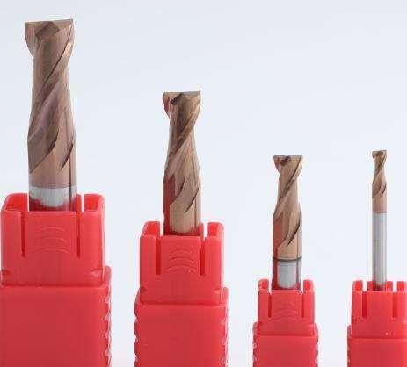  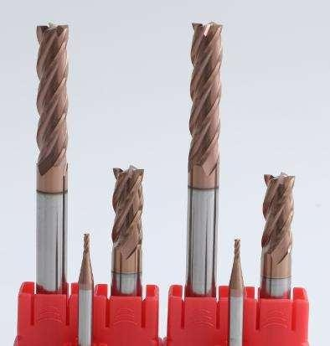
3.0*8*3D*50L | 251
4.0*10*4D*50L | 251
5.0*13*6D*50L
5.0*13*5D*50L | 439
1.5*4*60*50L
2.0*5*6D*50L
2.5*7*60*50L
3.0*8*6D*50L
3.5*10*6D*50L
4.0*10*6D*50L
4.5*12*6D*50L
6.0*15*6D*50L | 439
8.0*20*8D*60L | 840
10.0*25*10D*75L | 1391
12.0*30*12D*75L | 1948
14*3 5*14D*80L | 2942
14*45*140*100L | 2655
16*45*16D*100L | 3924
18*45*18D*100L | 4548
20*45*20D*100L | 5624
3.0*12*3D*75L | 408
4.0*16*4D*75L | 408
5.0*20*5D*75L | 677
6.0*25*6D*75L | 677
8.0*28*8D*75L | 1016
3.0*15*3D*100L | 383
4.0*20*4D*100L | 383
5.0*25*5D*100L | 677
6.0*30*6D*100L | 677
8.0*3 5*8D*100L | 1073
10.0*40*10D*100L | 1554
12.0*45*120*100L | 2132
6.0*40*6D*100L | 1326
8.0*50*8D*100L | 2379
10.0*50*10D*100L | 2784

HRC55 Square End Mill 3F 2F (for alminum)
Specification | PRICE/rub | Specification | PRICE/rub
1.0*3*4D*50L | 251 | 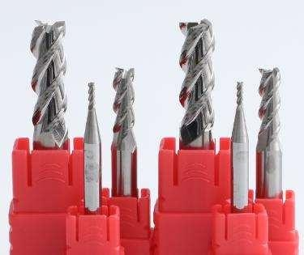  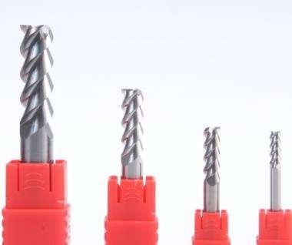
1.5*5*40*50L | 251
2.0*6*4D*50L | 251
2.5*8*40*50L | 251
3.0*9*3D*50L | 251
3.0*9*40*50L | 251
3.5*12*4D*50L | 251
4.0*12*4D*50L | 251
5.0*15*5D*50L | 439
5.0*15*6D*50L
6.0*18*6D*50L | 439
8.0*24*8D*60L | 840
10.0*30*10D*75L | 1391
12.0*36*12D*75L | 1948
14.0*35*14D*80L | 2942
14.0*45*14D*100L | 2655
16.0*45*16D*100L | 3924
18.0*45*18D*100L | 4548
20.0*45*20D*100L | 5624
3.0*12*3D*75L | 408
4.0*20*4D*75L | 408
5.0*20*5D*75L | 677
6.0*30*6D*75L | 677
8.0*3 5*8D*75L | 1016
3.0*15*3D*100L | 383
4.0*2 5*4D*100L | 434
5.0*25*5D*100L | 677
6.0*30*6D*100L | 677
8.0*40*8D*100L | 1073
10.0*40*10D*100L | 1554
12.0*45*12 D*100L | 2132
6.0*40*6D*150L | 1326
8.0*50*8D*150L | 1824
10.0*50*10D*150L | 3631
12.0*60*12D*150L | 3486
14.0*65*14D*150L | 4570
16.0*65*16D*150L | 6081
18.0*70*18D*150L | 9339
20.0*70*20D*100L | 8919

HRC55 Ball nose 2F (for steel)
Specification | PRICE/rub | Specification | PRICE/rub
R0.5*2*4D*50L-2T | 290 | R7.0*28*14D*150L-2T | 4831
R0.75*3*4D*50L-2T | 290 | R8.0*32*16D*150L-2T | 6431
R1.0*4*4D*50L-2T | 290 | R9.0*36*18D*150L-2T | 7160
R1.25*5*4D*50L-2T | 290 | R10.0*40*20D*150L-2T | 8919
R1.5*6*3D*50L-2T | 290 | 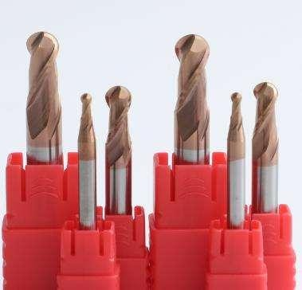
R1.5*6*4D*50L-2T | 290
R1.75*7*4D*50L-2T | 290
R2.0*8*4D*50L-2T | 290
R2.5*10*5D*50L-2T | 520
R1 *4*6D*50L-2T | 520
R1.5*6*6D*50L-2T | 520
R2*8*6D*50L*2T | 520
R2.5*10*6D*50L-2T | 520
R3.0*12*6D*50L-2T | 520
R3.5*14*8D*60L-2T | 916
R4.0*16*8D*60L-2T | 916
R4.5*18*10D*75L-2T | 1526
R5.0*20*10D*75L-2T | 1526
R5.5*22*12D*75-2T | 2146
R6.0*24*12D*75L-2T | 2146
R7*28*14D*80L-2T | 3182
R7.0*28*14D*100L-2T | 2921
R8.0*32*16D*100L-2T | 4070
R9.0*36*18D*100L-2T | 5003
R10.0*40*20D*100L-2T | 5828
R1.5*6*3D*75L-2T | 467
R2.0*8*4D*75L-2T | 467
R2.5*10*5D*75L-2T | 747
R3.0*12*6D*75L-2T | 747
R4.0*16*8D*75L-2T | 1153
R1.5*6*3D*100L-2T | 418
R2.0*8*4D*100L-2T | 418
R2.5*10*5D*100L-2T | 734
R3.0*12*6D*100L-2T | 734
R4.0*16*8D*100L-2T | 1187
R5.0*20*10D*100L-2T | 1637
R6.0*24*12D*100L-2T | 2202
R3.0*12*6D*150L-2T | 1400
R4.0*16*8D*150L-2T | 2517
R5.0*20*10D*150L-2T | 2945
R6.0*24*12D*150L-2T | 3688

HRC55 Corner Radius (for steel) 4F
Specification | PRICE/rub | Specification | PRICE/rub
3 R0. 5*8*4D*50L-4T | 449 | 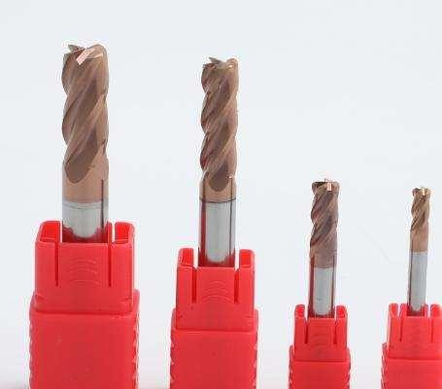
3R1.0*8*4D*50L-4T | 449
4R0.5*10*4D*50L-4T | 449
4R1.0*10*4D*50L-4T | 449
6R0.5*15*6D*50L-4T | 771
6R1.0*15*6D*50L-4T | 771
8R0.5*20*8D*60L-4T | 1253
8R1.0*20*8D*60L-4T | 1253
8R2.0*20*8D*60L-4T | 1253
10R0.5*25*10D*75L-4T | 1993
10R1.0*25*100*75L-4T | 1993
10R2.0*2 5* 100*75L-4T | 1993
10R3.0*2 5* 10D*7 5L-4T | 1993
12R0.5*30*12D*75L-4T | 2727
12R1.0*30*12D*75L-4T | 2727
12R2*30*12D*75L-4T | 2727
12R3.0*30*12D*75L-4T | 2727
4R0.5*15*4D*75L-4T | 567
4R1.0*15*4D*75L-4T | 567
6R0.5*20*6D*75L-4T | 916
6R1.0*20*6D*75L-4T | 916
8R0.5*28*8D*75L-4T | 1404
8R1,0*28*8D*75L-4T | 1404
4R0.5*20*4D*100L-4T | 593
4R1,0*20*4D*100L-4T | 593
6R0.5*30*6D*100L-4T | 881
6R1.0*30*60*100L-4T | 881
8R0.5*35*8D*100L-4T | 1510
8R1.0*35*8D*100L-4T | 1510
10R0.5*40*10D*100L-4T | 2236
10R1.0*40*10D*100L-4T | 2236
12R0.5*45*12D*100L-4T | 2848
12R1.0*45*12D*100L-4T | 2848
6R0.5*40*6D*150L-4T | 1661
6R1.0*40*6D*150L-4T | 1661
8R0.5*50*8D*150L-4T | 2280
8R1.0*50*80*150L-4T | 2280
10R0.5*50*100*150L-4T | 3419
10R1.0*50*10D*150L-4T | 3419
12R0.5*60*12D*150L-4T | 5567
12R1.0*60*120*150L-4T | 4268

HRC60 4F Square End Mill (for steel)
Specification | PRICE/rub | Specification | PRICE/rub
1.0*3*4D*50L | 447 | 10.0*50*10D*150L | 3832
1.5*4*40*50L | 447 | 12.0*60*12D*150L | 5426
2.0*5*40*50L | 447 | 14.0*60*14D*150L | 7035
2.5*7*4D*50L | 447 | 16.0*60*16D*150L | 8924
3.0*8*40*50L | 447 | 18.0*70*18D*150L | 11112
3.5*10*4D*50L | 447 | 20.0*70*20D*150L | 13737
3.0*8*3D*50L | 447 | 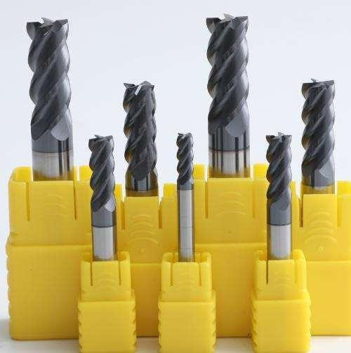
4.0*10*4D*50L | 447
5.0*13*6D*50L | 783
5.0*13*5D*50L | 783
1.0*3*6D*50L | 783
1.5*4*60*50L | 783
2.0*5*6D*50L | 783
2.5*7*60*50L | 783
3.0*8*6D*50L | 783
3.5*10*6D*50L | 783
4.0*10*6D*50L | 783
4.5*12*6D*50L | 783
6.0*15*6D*50L | 783
8.0*20*8D*60L | 1338
10.0*25*10D*75L | 2211
12.0*30*12D*75L | 3005
14*45*140*100L | 4565
16*45*16D*100L | 5678
18*45*18D*100L | 7147
20*45*20D*100L | 8580
3.0*12*3D*75L | 567
4.0*16*4D*75L | 567
5.0*20*5D*75L | 1026
6.0*25*6D*75L | 1026
8.0*28*8D*75L | 1597
3.0*15*3D*100L | 564
4.0*20*4D*100L | 564
5.0*25*5D*100L | 1000
6.0*30*6D*100L | 1000
8.0*3 5*8D*100L | 1639
10.0*40*10D*100L | 2377
12.0*45*120*100L | 3233
6.0*40*6D*100L | 1838
8.0*50*8D*100L | 2870

HRC 60 Ball nose 2F (for steel)
Specification | PRICE/rub | Specification | PRICE/rub
R0.5*2*4D*50L-2T | 447 | R7.0*28*14D*150L-2T | 7035
R0.75*3*4D*50L-2T | 447 | R8.0*32*16D*150L-2T | 8924
R1.0*4*4D*50L-2T | 447 | R9.0*36*18D*150L-2T | 11108
R1.25*5*4D*50L-2T | 447 | R10.0*40*20D*150L-2T | 13737
R1.5*6*3D*50L-2T | 447 | 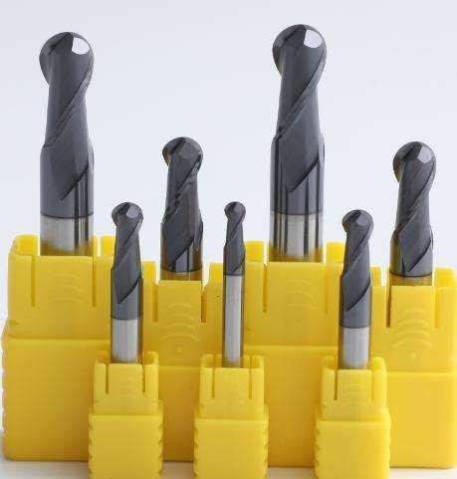
R1.5*6*4D*50L-2T | 447
R1.75*7*4D*50L-2T | 447
R2.0*8*4D*50L-2T | 447
R2.5*10*5D*50L-2T | 783
R1 *4*6D*50L-2T | 783
R1.5*6*6D*50L-2T | 783
R2*8*6D*50L*2T | 783
R2.5*10*6D*50L-2T | 783
R3.0*12*6D*50L-2T | 783
R3.5*14*8D*60L-2T | 1338
R4.0*16*8D*60L-2T | 1338
R4.5*18*10D*75L-2T | 2211
R5.0*20*10D*75L-2T | 2211
R5.5*22*12D*75-2T | 3005
R6.0*24*12D*75L-2T | 3005
R7.0*28*14D*100L-2T | 4565
R8.0*32*16D*100L-2T | 5678
R9.0*36*18D*100L-2T | 7147
R10.0*40*20D*100L-2T | 8580
R1.5*6*3D*75L-2T | 567
R2.0*8*4D*7 5L-2T | 567
R2.5*10*5D*75L-2T | 1026
R3.0*12*6D*75L-2T | 1026
R4.0*16*8D*7 5L-2T | 1597
R1.5*6*3D*100L-2T | 564
R2.0*8*4D*100L-2T | 564
R2.5*10*5D*100L-2T | 1000
R3.0*12*6D*100L-2T | 1000
R4.0*16*8D*100L-2T | 1639
R5.0*20* 10 D*100L-2T | 2377
R6.0*24*12D*100L-2T | 3233
R3.0*12*6D*150L-2T | 2397
R4.0*16*8D*150L-2T | 2870
R5.0*20*10D*150L-2T | 3832
R6.0*24*12D*150L-2T | 5426

HRC 60 Corner Radius (for steel) 4F
Specification | PRICE/rub | Specification | PRICE/rub
3R0.5*8*4D*50L-4T | 502 | 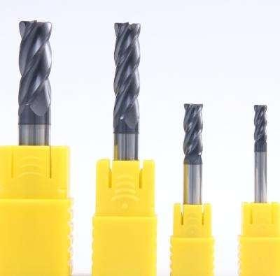
3R1.0*8*4D*50L-4T | 502
3R0.5*3D*50L-4T | 502
3R1*3D*50L-4T | 502
4R0.5*10*4D*50L-4T | 502
4R1.0*10*4D*50L-4T | 502
6R0.5*15*6D*50L-4T | 853
6R1.0*15*6D*50L-4T | 853
8R0.5*20*8D*60L-4T | 1457
8R1,0*20*8D*60L-4T | 1457
8R2.0*20*8D*60L-4T | 1457
10R0.5*25*10D*75L-4T | 2354
10R1.0*25*10D*75L-4T | 2354
10R2.0*25*10D*75L-4T | 2354
12R0.5*30*12D*75L-4T | 3160
12R1.0*30*12D*75L-4T | 3160
12R2*30*12D*75L-4T | 3160
3R0.5*3D*75L-4T | 602
3R1.0*3D*75L-4T | 602
4R0.5*16*4D*75L-4T | 602
4R1.0*16*4D*75L-4T | 602
6R0.5*25*6D*75L-4T | 1079
6R1.0*25*6D*75L-4T | 1079
8R0.5*28*8D*75L-4T | 1679
8R1,0*28*8D*75L-4T | 1679
4R0.5*20*4D*100L-4T | 627
4R1.0*20*4D*100L-4T | 627
6R0.5*30*6D*100L-4T | 1108
6R1.0*30*6D*100L-4T | 1108
8R0.5*35*8D*100L-4T | 1737
8R1.0*35*8D*100L-4T | 1737
10R0.5*40*10D*100L-4T | 2485
10R1.0*40*10D*100L-4T | 2485
12R0.5*45*12D*100L-4T | 3366
12R1.0*45*12D*100L-4T | 3366

HRC65 Square End Mill 4F (for steel)
Specification | PRICE/rub | Specification | PRICE/rub
1.0*3*4D*50L-4T | 530 | 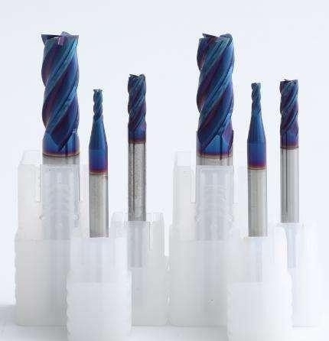
1.5*4*4D*50L-4T | 530
2.0*5*4D*50L-4T | 530
2.5*7*4D*50L-4T | 530
3.0*8*3D*50L-4T | 530
3.0*8*4D*50L-4T | 530
3.5*10*4D*50L-4T | 530
4.0*10*4D*50L-4T | 530
5.0*13*5D*50L-4T | 991
5.0*13*6D*50L-4T | 991
6.0*15*6D*50L-4T | 991
8.0*20*8D*60L-4T | 1616
10.0*25*10D*75L-4T | 2560
12.0*30*12D*75L-4T | 3415
14.0*45*14D*100L-4T | 4689
16.0*45*16D*100L-4T | 6055
18.0*45*18D*100L-4T | 7438
20.0*45*20D*100L-4T | 8900
3.0*12*3D*75L-4T | 716
4.0*16*4D*75L-4T | 716
6.0*25*6D*75L-4T | 1200
8.0*28*8D*7 5L-4T | 1846
3.0*15*3D*100L-4T | 672
4.0*20*4D*100L-4T | 672
5.0*25*5D*100L-4T | 1171
6.0*30*6D*100L-4T | 1171
8.0*3 5*8D* 100L-4T | 1923
10.0*40*10D*100L-4T | 2440
12.0*45*12 D*100L-4T | 3614
6.0*40*6D*150L-4T | 1858
8.0*50*8D*150L-4T | 2900
10.0*50*10D*150L-4T | 3874
12.0*60*12D*150L-4T | 5483
14.0*60*14D*150L-4T | 7110
16.0*60*16D*150L-4T | 9021
18.0*70*18D*150L-4T | 11230
20.0*70*20D*150L-4T | 13884

HRC65 Ballnose 2F (for steel)
Specification | PRICE/rub | Specification | PRICE/rub
R0.5*2*4D*5QL~2T | 530 | 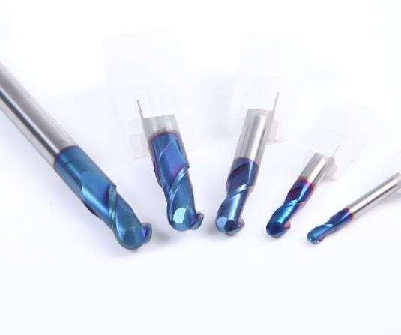
R0.75*3*4D*50L-2T | 530
R1.0*4*4D*50L-2T | 530
R1.25*5*4D*S0L-2T | 530
R1.5*6*3D*50L-2T | 530
R1.5*6*4D*50L-2T | 530
R2.0*8*4D*5QL-2T | 530
R2.5*10*5D*50L-2T | 991
R2.5*10*6D*50L-2T | 991
R3.0*12*6D*50L-2T | 991
R4.0*16*8D*60L-2T | 1616
R5.0*20*10D*75L-2T | 2560
R6.0*24*12D*75L-2T | 3415
R8.0*32*16D*100L-2T | 6055
R9*36*18D*100L-2T | 7664
R10.0*40*20D*100L-2T | 8900
R2.0*8*4D*75L-2T | 716
R3.0*12*6D*75L-2T | 1200
R4.0*16*8D*75L-2T | 1846
R2.0*8*4D*100L-2T | 672
R3.0*12*6D*100L-2T | 1171
R4.0*16*8D*100L-2T | 1923
R5*0*20*10D*100L-2T | 2440
R6.0*24*12D*100L-2T | 3614
R3.0*6D*150L-2T | 2382
R4.0*16*8D*150L-2T | 2900
R5.0*20*10D*150L-2T | 3874
R6*0*24*12D*150L-2T | 5483

HRC65 Corner Radius (for steel)
Specification | PRICE/rub | Specification | PRICE/rub
4R0.5*10*4D*50L-4T | 694 | 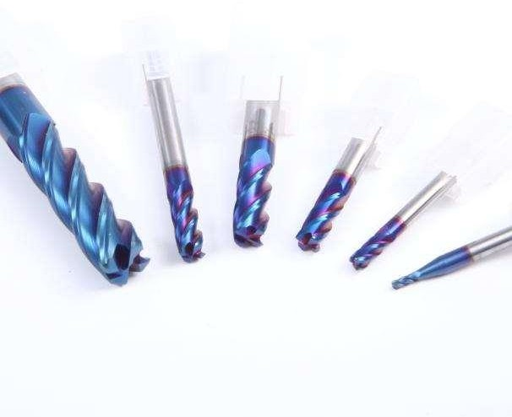
4R1.0*10*4D*50L-4T | 694
6R0.5*15*6D*50L-4T | 1130
6R1.0*15*6D*50L-4T | 1130
8R0.5*20*8D*60L-4T | 1867
8R1.0*20*8D*60L-4T | 1867
10R0.5*25*10D*75L-4T | 2954
10R1.0*25*10D*75L-4T | 2954
12R0.5*30*12D*75L-4T | 3876
12R1.0*30*12D*75L-4T | 3876
4R0.5*16*4D*75L-4T | 806
4R1.0*16*4D*75L-4T | 806
6R0.5*25*6D*75L-4T | 1363
6R1.0*25*6D*75L-4T | 1363
8R0.5*28*8D*75L-4T | 2077
8R1.0*28*8D*75L-4T | 2077
4R0.5*20*4D*100L-4T | 768
4R1.0*20*4D*100L-4T | 768
6R0.5*30*6D*100L-4T | 1326
6R1.0*30*6D*100L-4T | 1326
8R0.5*35*8D*100L-4T | 2210
8R1.0*35*8D*100L-4T | 2210
10R0.5*40*10D*100L-4T | 2865
10R1.0*40*10D*100L-4T | 2865
12R0.5*45*12D*100L-4T | 4075
12R1.0*45*12D*100L-4T | 075

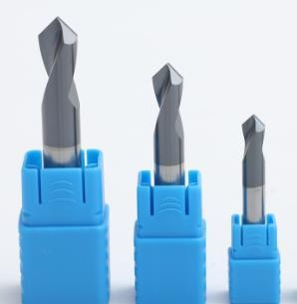
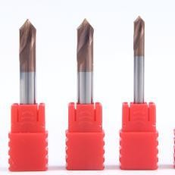
NC spotting drill
Specification | 45 HRC rub | 55 HRC rub
3*50 | 290 | 341
3*75 | 345 | 420
4*50 | 290 | 341
4*75 | 345 | 420
5*50 | 392 | 469
5*75 | 477 | 592
6*50 | 506 | 616
6*75 | 626 | 789
6*100 | 622 | 804
8*60 | 855 | 1081
8*75 | 979 | 1265
8*100 | 989 | 1306
10*75 | 1406 | 1844
10*100 | 1440 | 1926
12*75 | 1905 | 2530
12*100 | 1969 | 2662
14*100 | 2579 | 3517
16*100 | 3271 | 4490
18*100 | 4043 | 5578
20*100 | 4894 | 6785

Fine grinding rod
Specification | 45 HRC rub | 55 HRC rub
2*100 | 77 | 100
3*100 | 151 | 201
4*100 | 202 | 287
5*100 | 303 | 432
6*100 | 423 | 605
7*100 | 564 | 809
8*100 | 726 | 1042
9*100 | 908 | 1304
10*100 | 1108 | 1595
12*100 | 1573 | 2266
6*150 | 574 | 826
8*150 | 987 | 1423
10*150 | 1512 | 2183
12*150 | 2149 | 3106
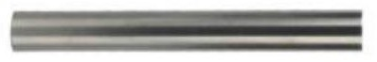
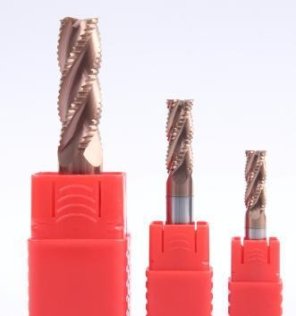
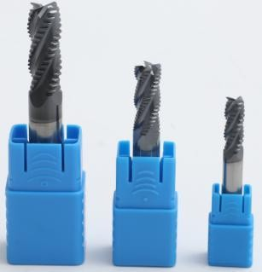

Roughing endmill 3F for Alu 4F for steel
Specification | 45 HRC Rough and mill rub | 55 HRC Rough and mill rub
4*50 | 420 | 471
5*50 | 555 | 632
6*50 | 702 | 812
8*60 | 1116 | 1342
10*75 | 1732 | 2171
12*75 | 2297 | 2921
8*100 | 1207 | 1523
10*100 | 1712 | 2198
12*100 | 2295 | 2989
14*100 | 3504 | 4442
16*100 | 4328 | 5545
18*100 | 5231 | 6768
20*100 | 6217 | 8106

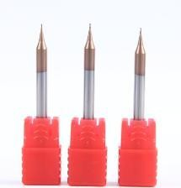
Micro endmill
Specification | 55 HRC rub
0.2*0.4*4D*50L*2I | 565
0.3*0.6*4D*50L*2 | 565
0.4*0.8*4D*50L*2I | 565
0.5*1*4D*50L*2F | 565
0.6*1.2*4D*50*2F | 565
0.7*1.4*4D*5OL*2 | 565
0.8*1.6*4D*50L*2I | 565
0.9*1.8*4D*50L*2I | 565

